Author: Xang Vo
2017/11/19
2017/11/19
Version: 0.1
Source: D:\xampp\htdocs\Laravel-AdminLTE-master\auth-with-activation-key\
Demo:
Php artisan serve
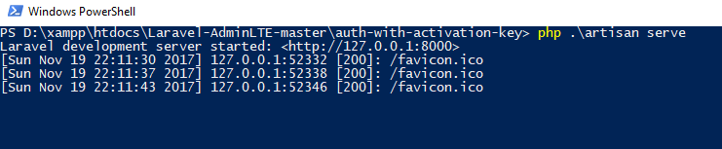

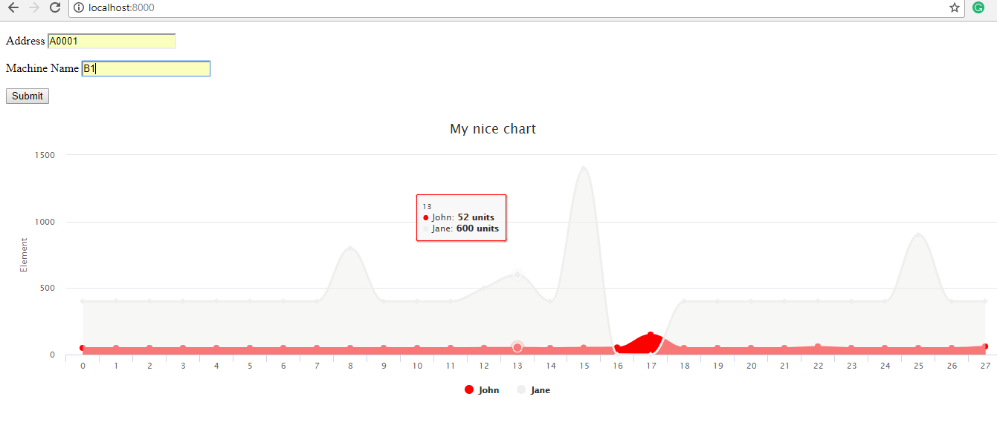

DB structure:
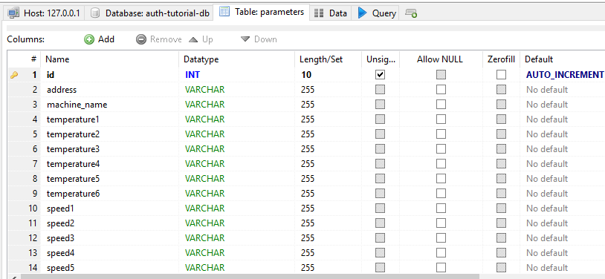
DB data:
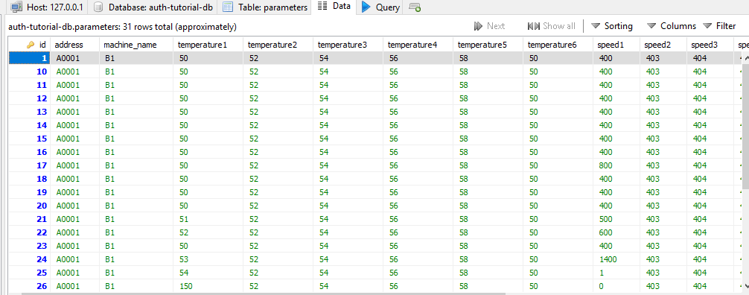

Reference:
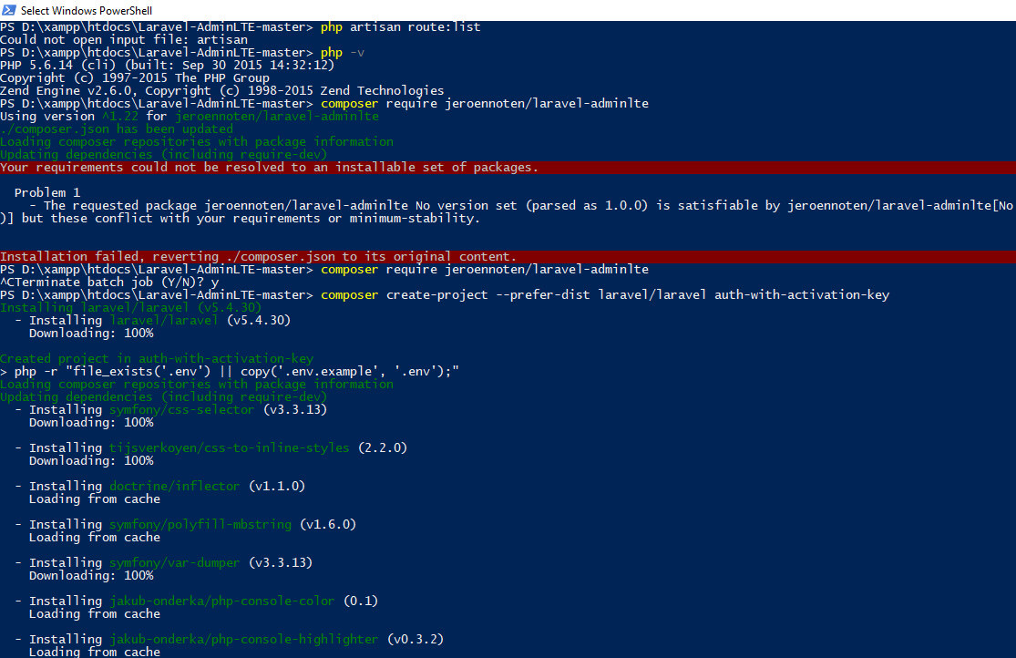
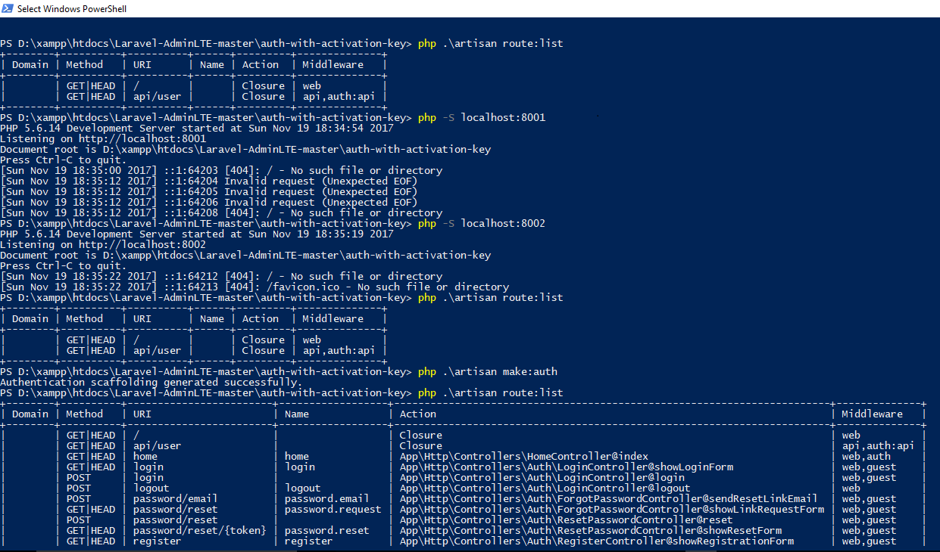

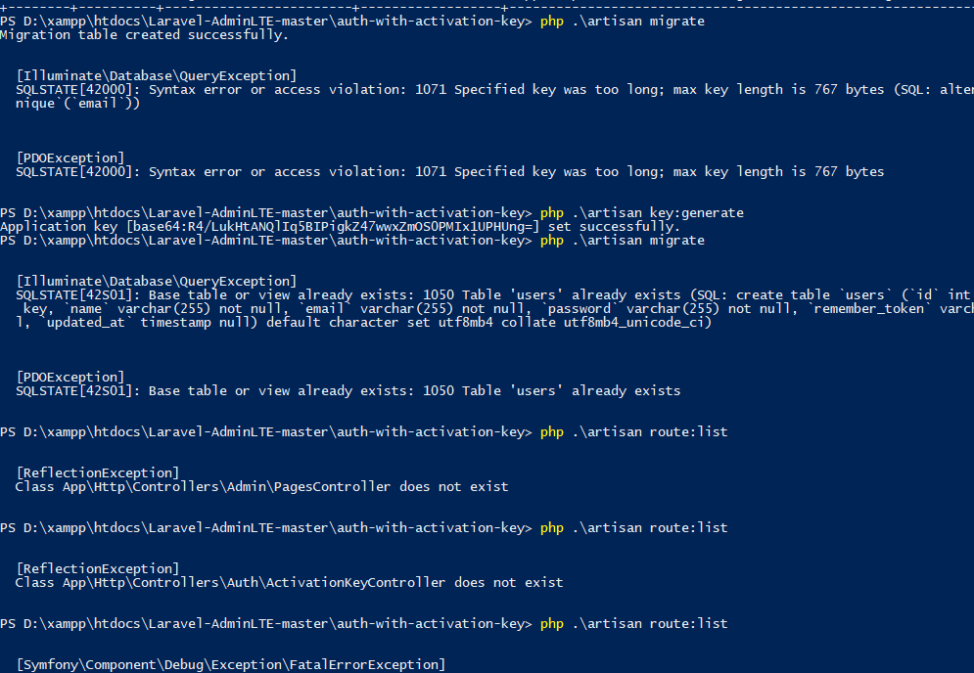

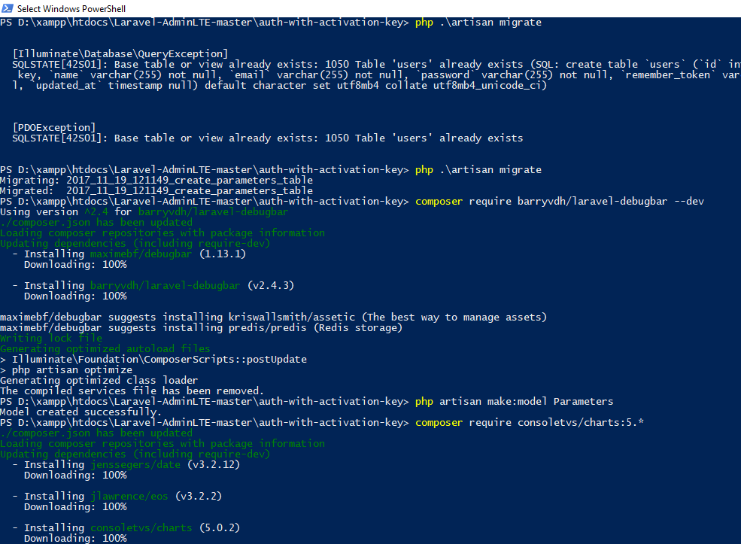

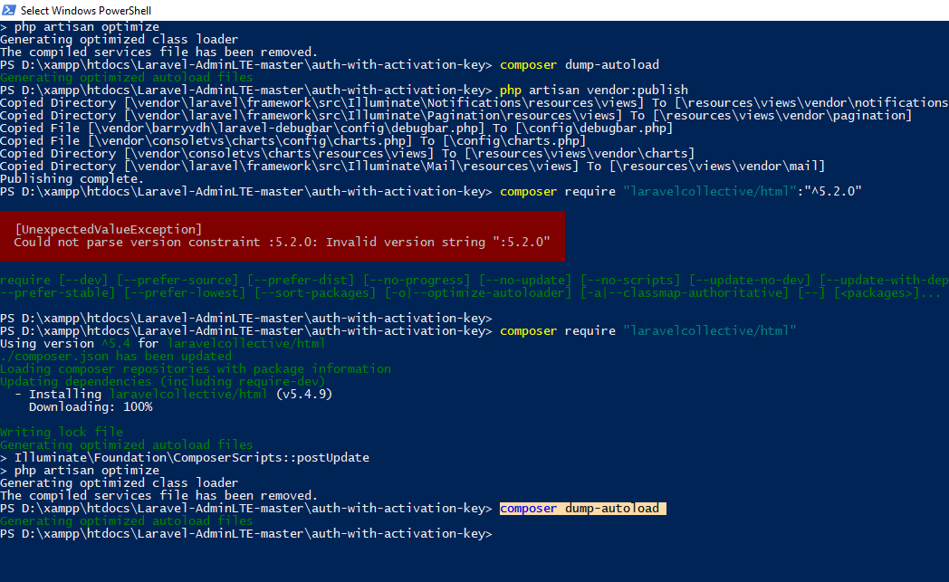
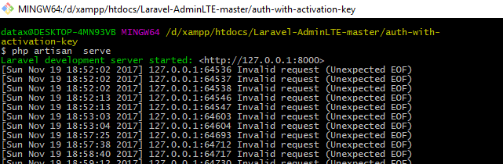

Link:
https://adminlte.io/themes/AdminLTE/index2.html
composer create-project laravel/laravel=5.2 <tenProject> --prefer-dist
https://github.com/jeroennoten/Laravel-AdminLTE
php artisan make:auth
https://adminlte.io/blog/integrate-adminlte-with-laravel
http://miftyisbored.com/a-complete-laravel-5-3-tutorial-for-user-authentication-with-activation-email/
https://github.com/barryvdh/laravel-debugbar
https://erik.cat/projects/Charts/docs/5#installation
https://laravelcollective.com/docs/5.2/html
http://itsolutionstuff.com/post/laravel-53-create-bootstrap-contact-us-form-using-form-requestexample.html

